


Papers for Journal of Research Technology & Engineering

*First Author, Second Author, Third Author

Faculty of Technology, University of Netherland
*Corresponding Author Email

Received:xxx; Revised: xxx; Accepted:xxx; Available online: xxx
Abstract: These instructions give you guidelines for preparing papers for JRTE JOURNALS. Use this document as a template if you are using Microsoft Word 6.0 or later. Do not delete the blank line immediately above the abstract; it sets the footnote at the bottom of this column. Don’t use all caps for research paper title.
Index Terms: Keywords should closely reflect the topic and should optimally characterize the paper. Use about four key words or phrases in alphabetical order, separated by commas.

1 Introduction

This document is a template for Microsoft Word versions 6.0 or later. JRTE staff will edit and complete the final formatting of your paper. (Line spacing should be 1.15)

2 Procedure for Paper Submission

2.1 Review Stage
Detailed submission guidelines can be found on the author resources Web pages. The guidelines are specific to each journal, so please be sure to refer to the correct journal when seeking information.
All authors are responsible for following these guidelines before submitting their manuscript. For further information on both submission guidelines, authors are strongly encouraged to refer to http://www.jrte.org.

2.2 Final Stage
For papers accepted for publication, it is essential that the electronic version of the manuscript and artwork match the hardcopy exactly.

2.3 Figures
All tables and figures will be processed as images. You need to embed the images in the paper itself. Please don’t send the images as separate files with the manuscript. Figures should be labeled as ‘Fig. 1’.

2.4 Copyright Form
An JRTE copyright form must accompany your final submission after being accepted by the journal.

3 Sections
As demonstrated in this document, the numbering for sections upper case Arabic numerals, then upper case Arabic numerals, separated by periods.

4 Citations
JRTE style is to citations in individual brackets, followed by a comma, e.g. “[1], [3]”.

Do not use “Ref. [2]” or “reference [2]” At the beginning of a sentence use the author names instead of “Reference [3],” e.g., “Alice and Brian [2] show ... .” Please note that references will be formatted by JRTE production staff in the same order provided by the author.

5 Equations
If you are using Word, use either the Microsoft Equation Editor or the Math Type add-on (http://www.mathtype.com) for equations in your paper (Insert | Object | Create New | Microsoft Equation or Math Type Equation).

Number equations consecutively with equation numbers in parentheses flush with the right margin, as in (1).

$a+b=c$ (1)

Be sure that the symbols in your equation have been defined before the equation appears or immediately follow.

Please note that math equations might need to be reformatted from the original submission for page layout reasons. This includes the possibility that some in-line equations will be made display equations to create better flow in a paragraph.

6 Helpful Hints

6.1 Figures and Tables
Because JRTE staff will do the final formatting of your paper, some figures may have to be moved from where they appeared in the original submission. Place figure captions below the figures; place table titles above the tables. If your figure has two parts, include the labels “(a)” and “(b)” as part of the artwork.

Please verify that the figures and tables you mention in the text actually exist. Figures and tables should be called out in the order they are to appear in the paper.

Please do not include figure captions as part of the figure.
Do not put borders around the outside of your figures.

For JRTE, please use the abbreviation “Fig.” even at the beginning of a sentence. Fig. 1. Magnetization as a function of applied field. Note that “Fig.” is abbreviated. There is a period after the figure number, followed by one space. It is good practice to briefly explain the significance of the figure in the caption.

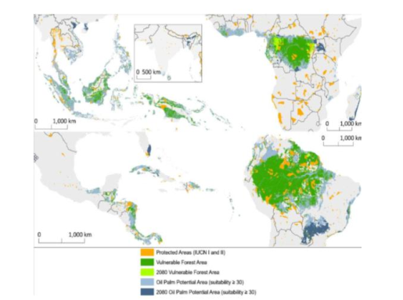

Fig. 1. World map

Table 1. Flow regime transition
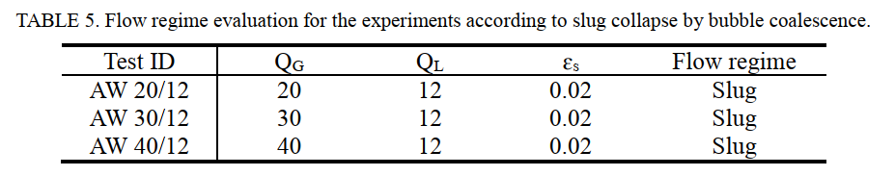
7 References
Unfortunately, the Computer Society document translator cannot handle automatic endnotes in Word; therefore, type the reference list at the end of the paper using the “References” style.

Please note that the references at the end of this document are in the preferred reference style. Within the text, use “et al.” when referencing a source with more than three authors. In the reference section, give all authors’ names; do not use “et al.” Do not place a space between an authors' initials.

8 Conclusion
Although a conclusion may review the main points of the paper, do not replicate the abstract as the conclusion. A conclusion might elaborate on the importance of the work or suggest applications and extensions.

Acknowledgment
The authors wish to thank A, B, C.

References
[1] L. Cheng, G. Ribatski, J. R. Thome, Two-Phase Flow Patterns and Flow-Pattern Maps: Fundamentals and Applications, Applied Mechanics Reviews, 3 (2), 1-28, 2008.
3: Volume
2: Issue
1-28: Page Numbers
Add DOI of the paper when it is available.

[2] Z. Li, G. Wang, Muhammad Yousaf ,Xiaohong Yang, Mamoru Ishii, Flow structure and flow regime transitions of downward two-phase flow in large diameter pipes, International Journal of Heat and Mass Transfer, 118, 812-822, 2018.

[3] E.B. Christopher, Fundamentals of Multiphase Flows. Cambridge University Press, 163-194, 2005.

[4] C.P. Fairhurst,. Upward Vertical Two-Phase Flow through an Annulus, Multi-Phase Flow Proceedings of the 4th International Conference : Chapter 20, 1989.

[5] European Commission, Carbon Capture and Utilization,http://s3platform.jrc.ec.europa.eu/carboncapture-and-utilization, (accessed 13th April 2019).

[6] J. Williams, “Narrow-Band Analyzer,” PhD dissertation, Dept. of Electrical Eng., Harvard Univ., Cambridge, Mass., 1993. (Thesis or dissertation).

